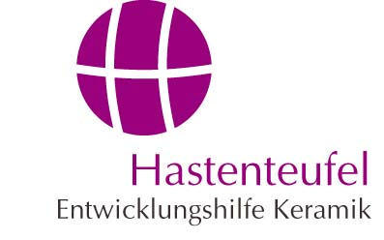

European Union – Cambodia project

>> Introduction

Through the period of October 2006 to October 2007 in conjunction with the European Union’s ASIA INVEST II program we were able to set forth with our long term social development project in Cambodia. Our partner in this endeavor was again the Handwerkskammer of Koblenz, who coordinates craft related EU projects.

>> October 2006

During a 2 week workshop, local Cambodian potters were taught the fundamental basics for the safe and efficient use of the existing kiln in their village, and for the imported prepared glazes from Thailand. A prerequisite for this was the restoration of a kiln using traditional methods of construction. It was necessary to hold the workshops in one of the local villages so that the lessons could take place under the same working conditions that the local potters would later face. The village of Banh Chhkol was chosen as the most favorable location for the workshop.

>> October 2007

This year the workshop was held in the pottery village of Ondoung Rossey. As in the previous year, the workshop concentrated on the use of the kiln and glazes. Due to the complexity of these topics an in-depth approach was used to assure their appropriate use. The high prices of the imported glazes from Thailand made it necessary to develop personal contacts to the appropriate raw material suppliers in neighboring Vietnam. Through these contacts, glazes were selected and brought to Cambodia, and then subsequently tested under normal working conditions.

>> Comprehensive estimation

During these two intensive workshops the kilns were restored and then fired several times with the local potters. Through this practical orientation the local potters could experience how their kilns could be fired both cost and energy efficiently when used correctly. Not only did the energy costs go down, but the polluting emissions were substantially reduced as well.
Through the courses on the use of glazes, the participants were taught about the process of adding color to their glaze recipes as well as the correct approach to setting the correct glaze consistency. Several glazing methods such as pouring glaze over the ware and dipping the ware into the glaze were practiced together.
Through the availability of cheap glaze raw materials from Vietnam the local potters are now able to produce glazed ceramic products. This will enable them to effectively compete with the available imported ceramics.

HASTENTEUFEL – Development assistance in ceramics
Gartenstr. 8 • D-56206 Hilgert • Tel: +49 (0) 26 24 / 945640
eMail: info@entwicklungshilfe-keramik.de • www.entwicklungshilfe-keramik.de

